Restaurant Order & Inventory Management System
Tables
- Customers
Stores customer details.
CREATE TABLE Customers (
customer_id INT PRIMARY KEY,
name VARCHAR(100),
phone VARCHAR(15),
email VARCHAR(100),
address VARCHAR(255)
);
- Menu_Items
Stores details of dishes served.
CREATE TABLE Menu_Items (
item_id INT PRIMARY KEY,
item_name VARCHAR(100),
category VARCHAR(50), -- e.g., Starter, Main Course, Dessert
price DECIMAL(10,2),
availability_status VARCHAR(20) -- Available / Out of Stock
);
- Orders
Stores order details for customers.
CREATE TABLE Orders (
order_id INT PRIMARY KEY,
customer_id INT,
order_date DATE,
total_amount DECIMAL(10,2),
status VARCHAR(20), -- Placed / Completed / Cancelled
FOREIGN KEY (customer_id) REFERENCES Customers(customer_id)
);
- Order_Items
Links orders with menu items.
CREATE TABLE Order_Items (
order_item_id INT PRIMARY KEY,
order_id INT,
item_id INT,
quantity INT,
subtotal DECIMAL(10,2),
FOREIGN KEY (order_id) REFERENCES Orders(order_id),
FOREIGN KEY (item_id) REFERENCES Menu_Items(item_id)
);
- Inventory
Tracks stock of ingredients used in dishes.
CREATE TABLE Inventory (
item_code INT PRIMARY KEY,
ingredient_name VARCHAR(100),
quantity_in_stock INT,
unit VARCHAR(20), -- e.g., kg, liters, pieces
reorder_level INT
);
- Suppliers
Stores supplier information for restocking ingredients.
CREATE TABLE Suppliers (
supplier_id INT PRIMARY KEY,
supplier_name VARCHAR(100),
phone VARCHAR(15),
email VARCHAR(100)
);
- Purchases
Tracks ingredient purchases from suppliers.
CREATE TABLE Purchases (
purchase_id INT PRIMARY KEY,
supplier_id INT,
item_code INT,
purchase_date DATE,
quantity INT,
total_cost DECIMAL(10,2),
FOREIGN KEY (supplier_id) REFERENCES Suppliers(supplier_id),
FOREIGN KEY (item_code) REFERENCES Inventory(item_code)
);

Tasks
🔹 Basic Queries
- Insert sample data (5–10 rows per table).
  - Customers
INSERT INTO Customers VALUES
(1, 'Anwar Dudekula', '6302167307', 'anwar@gmail.com', 'Nandyal, AP'),
(2, 'Hussain Vali', '9158753485', 'hussain@gmail.com', 'Warangal, TS'),
(3, 'Shasha Vali', '9640170186', 'shasha@gmail.com', 'Kurnool, AP'),
(4, 'Rahul Dravid', '9988776655', 'rahul@gmail.com', 'Bangalore, KA'),
(5, 'Virat Kohli', '8877665544', 'virat@gmail.com', 'Delhi, DL'),
(6, 'Rohit Sharma', '7766554433', 'rohit@gmail.com', 'Mumbai, MH');

  - Menu_Items
INSERT INTO Menu_Items VALUES
(101, 'Chicken Biryani', 'Main Course', 250.00, 'Available'),
(102, 'Paneer Butter Masala', 'Main Course', 180.00, 'Available'),
(103, 'Tandoori Roti', 'Breads', 30.00, 'Available'),
(104, 'Gulab Jamun', 'Dessert', 50.00, 'Available'),
(105, 'Coke', 'Beverage', 40.00, 'Available'),
(106, 'Mutton Biryani', 'Main Course', 350.00, 'Available'),
(107, 'Ice Cream', 'Dessert', 60.00, 'Out of Stock');

  - Orders
INSERT INTO Orders VALUES
(501, 1, '2025-10-01', 280.00, 'Completed'),
(502, 2, '2025-10-02', 500.00, 'Placed'),
(503, 3, '2025-10-05', 180.00, 'Cancelled'),
(504, 1, '2025-10-10', 50.00, 'Completed'),
(505, 4, '2025-11-01', 250.00, 'Placed'),
(506, 5, '2025-11-02', 400.00, 'Completed');

  - Order_Items
INSERT INTO Order_Items VALUES
(1, 501, 101, 1, 250.00),
(2, 501, 103, 1, 30.00),
(3, 502, 101, 2, 500.00),
(4, 503, 102, 1, 180.00),
(5, 504, 104, 1, 50.00),
(6, 505, 101, 1, 250.00),
(7, 506, 105, 10, 400.00);

  - Inventory
INSERT INTO Inventory VALUES
(201, 'Basmati Rice', 50, 'kg', 10),
(202, 'Chicken', 20, 'kg', 5),
(203, 'Paneer', 15, 'kg', 5),
(204, 'Milk', 30, 'liters', 10),
(205, 'Coke Cans', 100, 'pieces', 20);

  - Suppliers
INSERT INTO Suppliers VALUES
(301, 'Fresh Farms', '1112223333', 'contact@freshfarms.com'),
(302, 'Dairy Best', '4445556666', 'sales@dairybest.com'),
(303, 'Dairy Best', '4445556666', 'sales@dairybest.com'),
(304, 'Fresh Farms', '1112223333', 'contact@freshfarms.com'),
(305, 'Beverage Corp', '7778889999', 'supply@bevcorp.com'),
(306, 'Beverage Corp', '7778889999', 'supply@bevcorp.com');

  - Purchases
INSERT INTO Purchases VALUES
(601, 301, 201, '2025-09-01', 100, 5000.00),
(602, 302, 204, '2025-09-05', 50, 2000.00),
(603, 301, 202, '2025-09-10', 40, 6000.00),
(604, 302, 204, '2025-09-15', 70, 2800.00),
(605, 301, 203, '2025-09-20', 10, 1500.00),
(606, 301, 201, '2025-10-01', 50, 2500.00);

- Display all menu items with price greater than 300.
SELECT * FROM Menu_Items
WHERE price > 300;
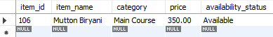

- List all customers who placed orders in October 2025.
SELECT DISTINCT c.name, c.email
FROM Customers c
JOIN Orders o ON c.customer_id = o.customer_id
WHERE MONTH(o.order_date) = 10 AND YEAR(o.order_date) = 2025;
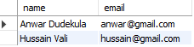

- Find all menu items marked as “Out of Stock.”
SELECT * FROM Menu_Items
WHERE availability_status = 'Out of Stock';
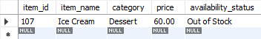

- Show details of all completed orders.
SELECT * FROM Orders
WHERE status = 'Completed';
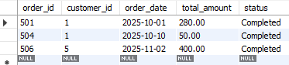

🔹 Joins
- List customer names with their ordered item names.
SELECT c.name, m.item_name
FROM Customers c
JOIN Orders o ON c.customer_id = o.customer_id
JOIN Order_Items oi ON o.order_id = oi.order_id
JOIN Menu_Items m ON oi.item_id = m.item_id;
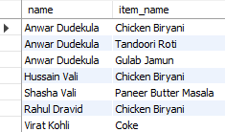

- Display order details with item name and quantity.
SELECT o.order_id, m.item_name, oi.quantity
FROM Order_Items oi
JOIN Menu_Items m ON oi.item_id = m.item_id
JOIN Orders o ON oi.order_id = o.order_id;
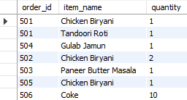

- Show all orders with total amount and customer details.
SELECT o.order_id, o.total_amount, c.name, c.email
FROM Orders o
JOIN Customers c ON o.customer_id = c.customer_id;
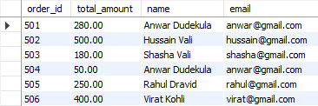

- List suppliers with ingredients they supply.
SELECT s.supplier_name, i.ingredient_name
FROM Suppliers s
JOIN Purchases p ON s.supplier_id = p.supplier_id
JOIN Inventory i ON p.item_code = i.item_code;
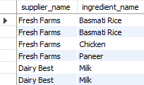

- Get details of menu items used in orders along with their category.
SELECT DISTINCT m.item_name, m.category, m.price
FROM Menu_Items m
JOIN Order_Items oi ON m.item_id = oi.item_id;
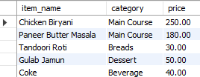

🔹 Aggregate Functions
- Count total number of orders placed in a month.
SELECT COUNT(*) AS Total_Orders_Oct
FROM Orders
WHERE order_date BETWEEN '2025-10-01' AND '2025-10-31';
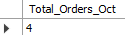
SELECT COUNT(*) AS Total_Orders_Nov
FROM Orders
WHERE order_date BETWEEN '2025-11-01' AND '2025-11-30';
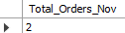

- Find total revenue earned.
SELECT SUM(total_amount) AS Total_Revenue
FROM Orders
WHERE status = 'Completed';
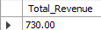

- Get the average order amount.
SELECT AVG(total_amount) AS Avg_Order_Value FROM Orders;
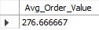

- Show the most expensive dish on the menu.
SELECT item_name, price FROM Menu_Items
WHERE price = (SELECT MAX(price) FROM Menu_Items);
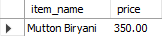

- Find the total quantity of each ingredient in stock.
SELECT ingredient_name, quantity_in_stock, unit FROM Inventory;
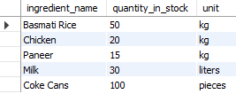

🔹 Subqueries
- Find customers who haven’t placed any orders.
SELECT name FROM Customers
WHERE customer_id NOT IN (SELECT DISTINCT customer_id FROM Orders);
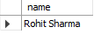

- Retrieve menu items that were never ordered.
SELECT item_name FROM Menu_Items
WHERE item_id NOT IN (SELECT DISTINCT item_id FROM Order_Items);
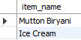

- Get ingredients below reorder level.
SELECT ingredient_name, quantity_in_stock
FROM Inventory WHERE quantity_in_stock < reorder_level;
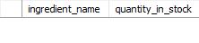
- Find suppliers who haven’t made any recent deliveries.
SELECT supplier_name, email
FROM Suppliers
WHERE supplier_id NOT IN (
SELECT DISTINCT supplier_id
FROM Purchases
WHERE purchase_date > DATE_SUB(CURDATE(), INTERVAL 30 DAY)
);
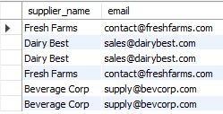

- Get orders whose total amount is above average.
SELECT * FROM Orders
WHERE total_amount > (SELECT AVG(total_amount) FROM Orders);
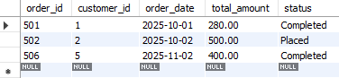

🔹 Updates & Deletes
- Update menu item availability after an order is completed.
UPDATE Menu_Items
SET availability_status = 'Available'
WHERE item_id = 107;
select * from menu_items;
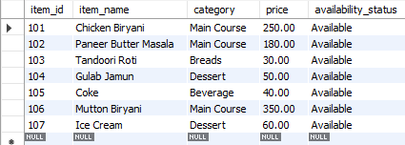

- Change supplier contact details.
UPDATE Suppliers
SET phone = '9876543210'
WHERE supplier_id = 301;
select * from suppliers;
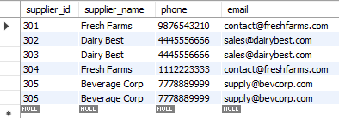

- Delete cancelled orders.
DELETE FROM Order_Items
WHERE order_id IN (SELECT order_id FROM Orders WHERE status = 'Cancelled');
DELETE FROM Orders
WHERE status = 'Cancelled';
select * from orders;
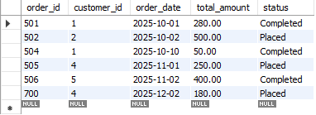

- Update ingredient stock after new purchase.
UPDATE Inventory
SET quantity_in_stock = quantity_in_stock + 20
WHERE item_code = 201;
select * from inventory;
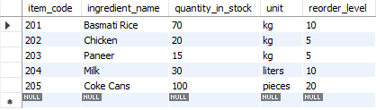

- Delete customers with no order history.
DELETE FROM Customers
WHERE customer_id NOT IN (SELECT DISTINCT customer_id FROM Orders);
select * from customers;
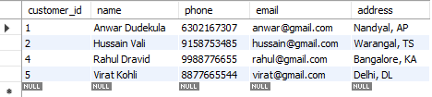

🔹 Advanced (Triggers, Views, Procedures)
- Trigger: Reduce inventory quantity automatically when an order is placed.
DELIMITER $$
CREATE TRIGGER ReduceInventory_OnOrder
AFTER INSERT ON Order_Items
FOR EACH ROW
BEGIN
-- Simplified Logic: Assuming Menu Item 101 (Chicken Biryani) uses Ingredient 201 (Rice)
-- In a real production system, you would query a Recipe table to get exact ingredients.
IF NEW.item_id = 101 THEN
UPDATE Inventory
SET quantity_in_stock = quantity_in_stock - NEW.quantity
WHERE item_code = 201;
END IF;
END $$
DELIMITER ;
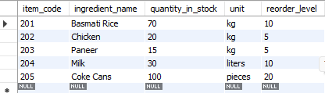

- View: Show combined order report (Customer, Items, Total Amount).
CREATE OR REPLACE VIEW View_Order_Report AS
SELECT
c.name AS Customer_Name,
o.order_id AS Order_ID,
m.item_name AS Item,
oi.quantity AS Quantity,
o.total_amount AS Total_Bill
FROM Customers c
JOIN Orders o ON c.customer_id = o.customer_id
JOIN Order_Items oi ON o.order_id = oi.order_id
JOIN Menu_Items m ON oi.item_id = m.item_id;
select * from View_Order_Report;
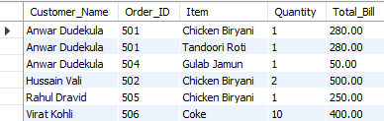

- Procedure: Generate daily sales summary.
DELIMITER $$
CREATE PROCEDURE Procedure_DailySales(IN report_date DATE)
BEGIN
SELECT
report_date AS Date,
COUNT(order_id) AS Total_Orders,
IFNULL(SUM(total_amount), 0.00) AS Total_Revenue
FROM Orders
WHERE order_date = report_date AND status = 'Completed';
END $$
DELIMITER ;
CALL Procedure_DailySales('2025-10-01');
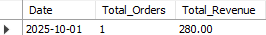

- Transaction: Add order and order items only if all items are available.
DELIMITER $$
CREATE PROCEDURE Transaction_PlaceOrder(
IN p_order_id INT,
IN p_cust_id INT,
IN p_item_id INT,
IN p_qty INT,
IN p_amount DECIMAL(10,2)
)
BEGIN
DECLARE current_stock INT;

-- 1. Check Stock Level (Example: checking stock for Ingredient 201)
SELECT quantity_in_stock INTO current_stock FROM Inventory WHERE item_code = 201;

-- 2. Start Transaction
START TRANSACTION;

IF current_stock >= p_qty THEN
-- Insert Order
INSERT INTO Orders (order_id, customer_id, order_date, total_amount, status)
VALUES (p_order_id, p_cust_id, CURDATE(), p_amount, 'Placed');

-- Insert Order Item
-- (Note: The Trigger 'ReduceInventory_OnOrder' defined above will fire here automatically)
INSERT INTO Order_Items (order_item_id, order_id, item_id, quantity, subtotal)
VALUES (p_order_id * 100, p_order_id, p_item_id, p_qty, p_amount);

COMMIT;
SELECT 'Success: Order Placed' AS Status;
ELSE
ROLLBACK;
SELECT 'Failed: Insufficient Stock' AS Status;
END IF;
END $$
DELIMITER ;
CALL Transaction_PlaceOrder(700, 4, 102, 1, 180.00);
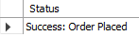
select * from orders;
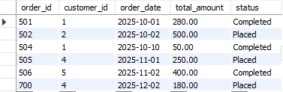
select * from order_items;
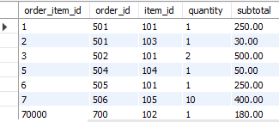

🔹 Reports / Analysis
- Top 5 selling dishes by quantity.
SELECT m.item_name, SUM(oi.quantity) as total_sold
FROM Menu_Items m
JOIN Order_Items oi ON m.item_id = oi.item_id
GROUP BY m.item_name
ORDER BY total_sold DESC
LIMIT 5;
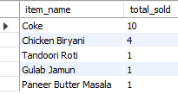
- Monthly revenue report for 2025.
SELECT MONTHNAME(order_date) as Month, SUM(total_amount) as Revenue
FROM Orders
WHERE YEAR(order_date) = 2025
GROUP BY MONTHNAME(order_date);
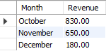

- Most frequent customers and their total spending.
SELECT c.name, COUNT(o.order_id) as orders_placed, SUM(o.total_amount) as total_spent
FROM Customers c
JOIN Orders o ON c.customer_id = o.customer_id
GROUP BY c.name
ORDER BY orders_placed DESC;
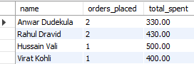

- Ingredients most frequently restocked.
SELECT i.ingredient_name, COUNT(p.purchase_id) as restock_count
FROM Inventory i
JOIN Purchases p ON i.item_code = p.item_code
GROUP BY i.ingredient_name
ORDER BY restock_count DESC;
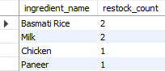

- Supplier who provides the highest quantity of items.
SELECT s.supplier_name, SUM(p.quantity) as total_supplied
FROM Suppliers s
JOIN Purchases p ON s.supplier_id = p.supplier_id
GROUP BY s.supplier_name
ORDER BY total_supplied DESC
LIMIT 1;
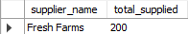

- Category of dishes generating the highest revenue.
SELECT m.category, SUM(oi.subtotal) as revenue
FROM Menu_Items m
JOIN Order_Items oi ON m.item_id = oi.item_id
GROUP BY m.category
ORDER BY revenue DESC
LIMIT 1;
